Intro
Neural network - A model containing at least one hidden layer. A deep neural network is a type of neural network containing more than one hidden layer.
One-hot encoding - Representing categorical data as a vector in which:
• One element is set to 1.
• All other elements are set to 0.
Weight - A value that a model multiplies by another value.
Embedding Space and Static Embeddings
Embedding space - The d-dimensional vector space that features from a higher-dimensional vector space are mapped to. Embedding space is trained to capture structure that is meaningful for the intended application.
Embedding vector - Broadly speaking, an array of floating-point numbers taken from any hidden layer that describe the inputs to that hidden layer. Often, an embedding vector is the array of floating-point numbers trained in an embedding layer.
Interactive Exercises
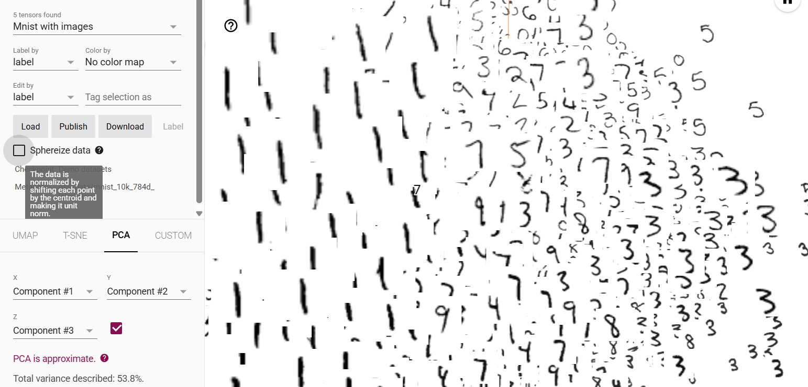
Obtaining Embeddings
Bag of words - A representation of the words in a phrase or passage, irrespective of order.
BERT (Bidirectional Encoder Representations from Transformers) - A model architecture for text representation. A trained BERT model can act as part of a larger model for text classification or other ML tasks.
Embedding layer - A special hidden layer that trains on a high-dimensional categorical feature to gradually learn a lower dimension embedding vector. An embedding layer enables a neural network to train far more efficiently than training just on the high-dimensional categorical feature.
Embedding vector - Broadly speaking, an array of floating-point numbers taken from any hidden layer that describe the inputs to that hidden layer. Often, an embedding vector is the array of floating-point numbers trained in an embedding layer.
Neural network - A model containing at least one hidden layer. A deep neural network is a type of neural network containing more than one hidden layer.
Positional encoding - A technique to add information about the position of a token in a sequence to the token's embedding. Transformer models use positional encoding to better understand the relationship between different parts of the sequence.
Softmax - A function that determines probabilities for each possible class in a multi-class classification model. The probabilities add up to exactly 1.0.
Test


